Wealth management system

When we run the application the following page will open by spring security the password is encrypted at the database side

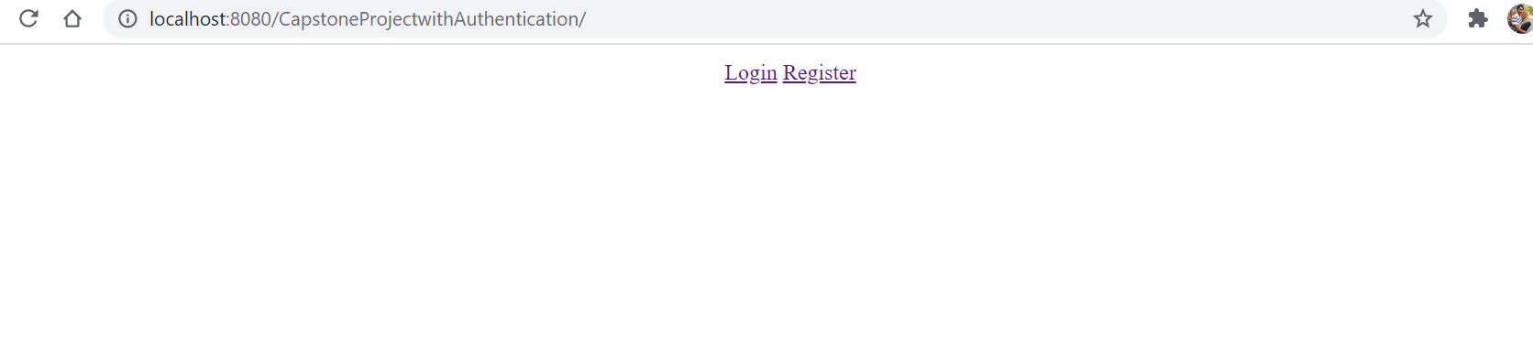

When we click on the login button the following page renders

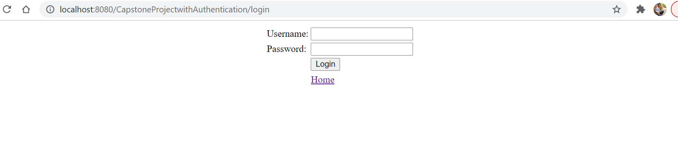

When we click on the register button following page renders

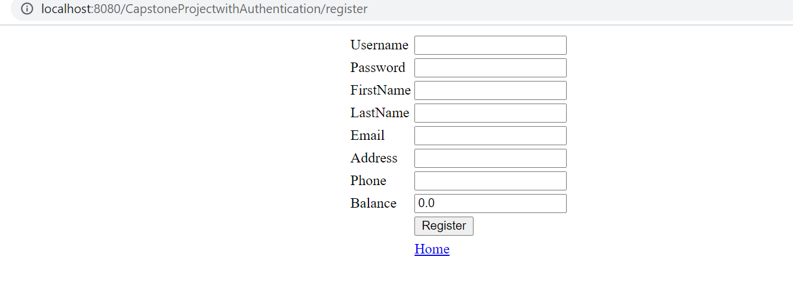

In the login page if the username and password is not found then it will re render to the home page you can see that it is wrong login in the url as error



When user given right credentials the menu page will open

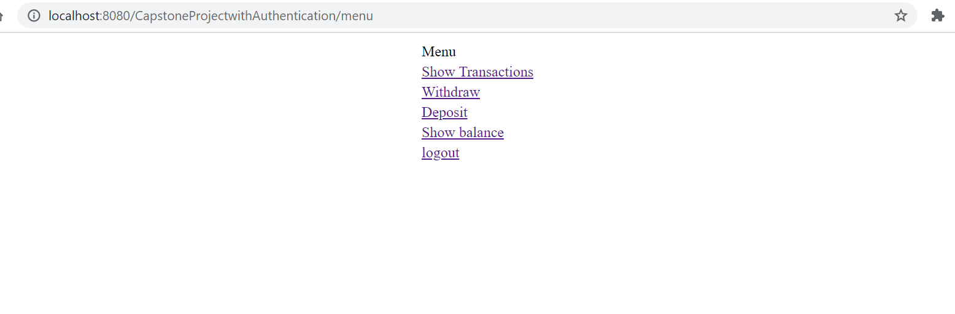

When user selected the logout option then the user will be logged out and session is invalidated

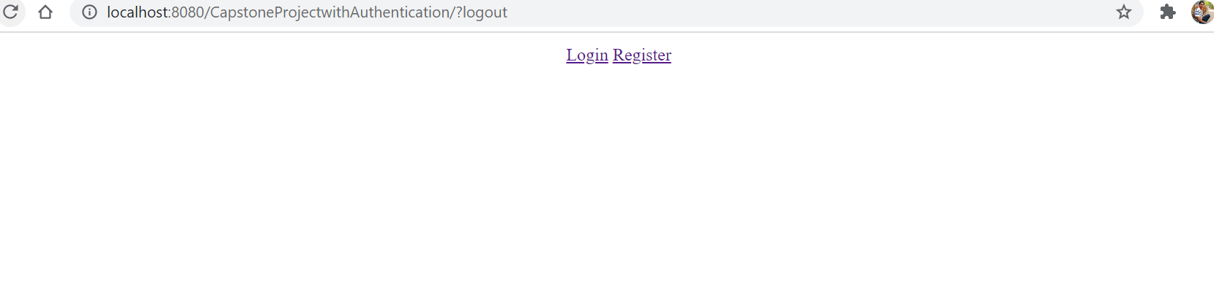

When registering If the details are correctly mentioned the following page renders and you can go back by clicking on the home reference

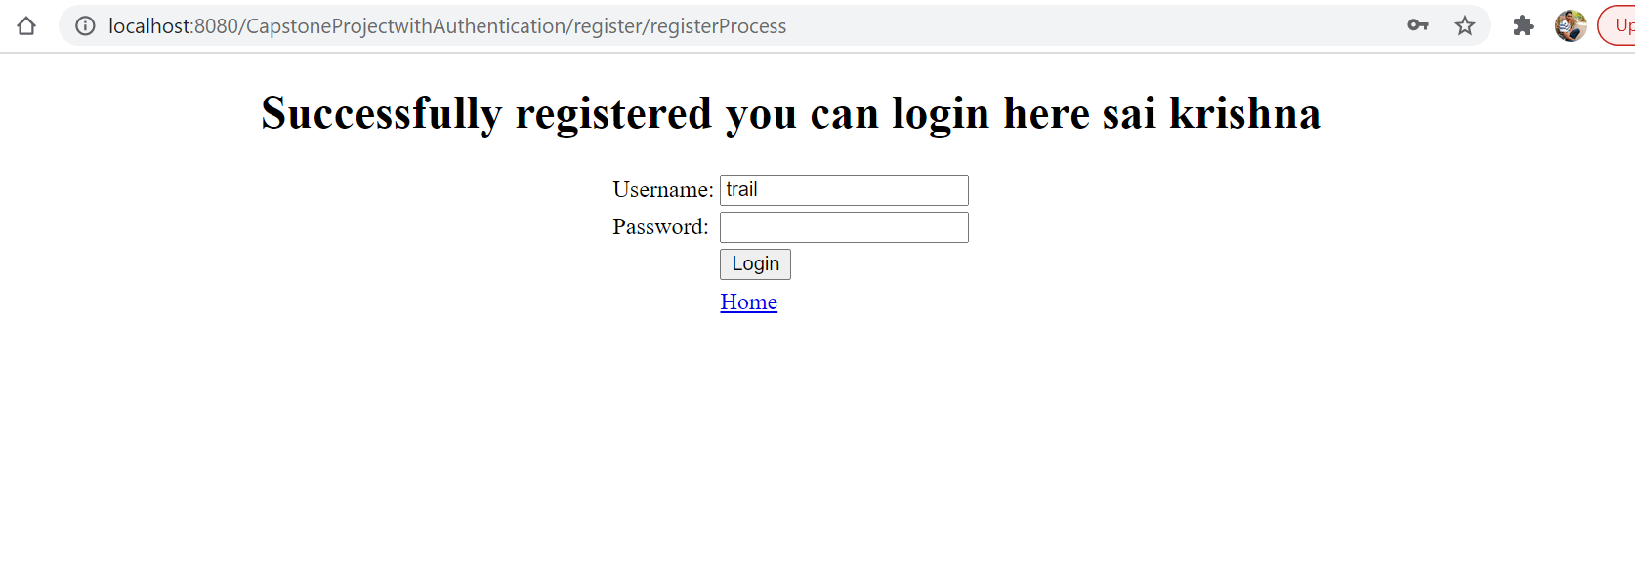

You can see that the records are creating at the database

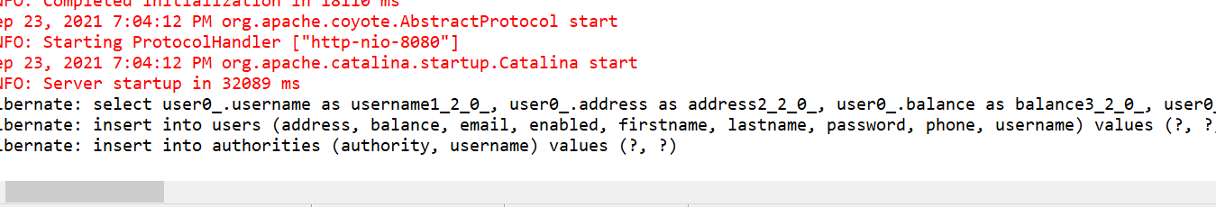

If details are not correctly mentioned in registration following page renders

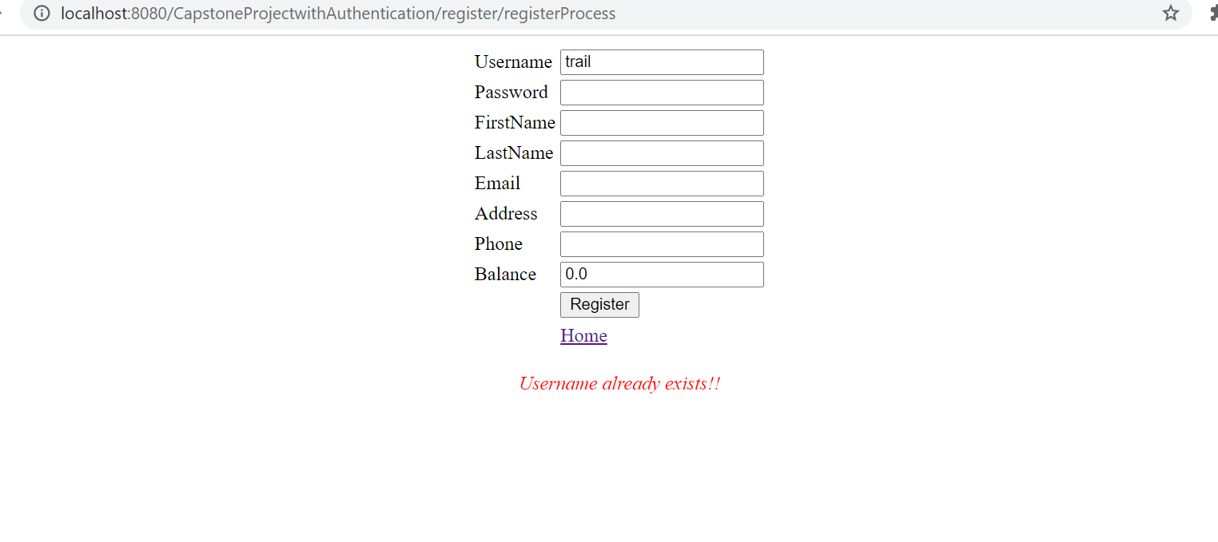

When we click on show transaction after logging then transactions of the logged user is shown as below and you can navigate back to home page by clicking on the hyper reference go to menu

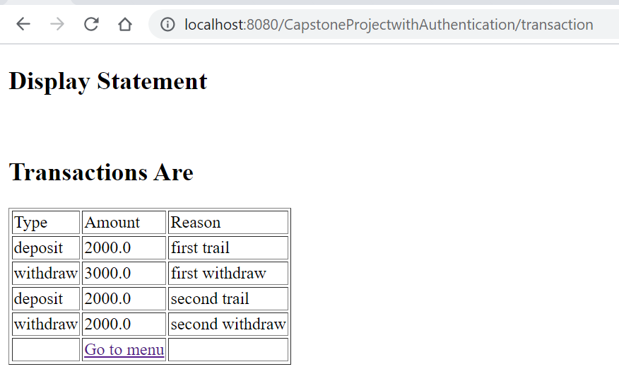

When we click on the deposit hyper reference following page renders and you can process the transaction on scuccesful transaction it will reflect in the database and the user balance too.

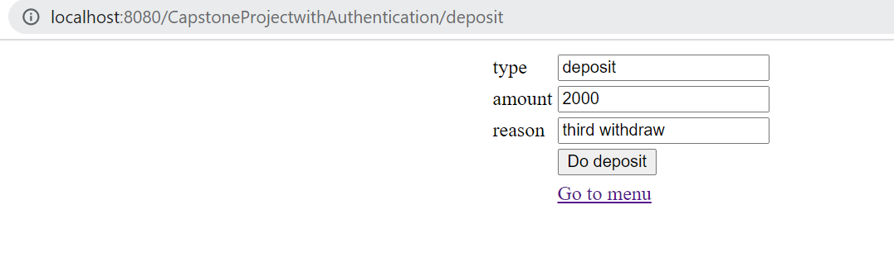

For successful deposit will be as follows

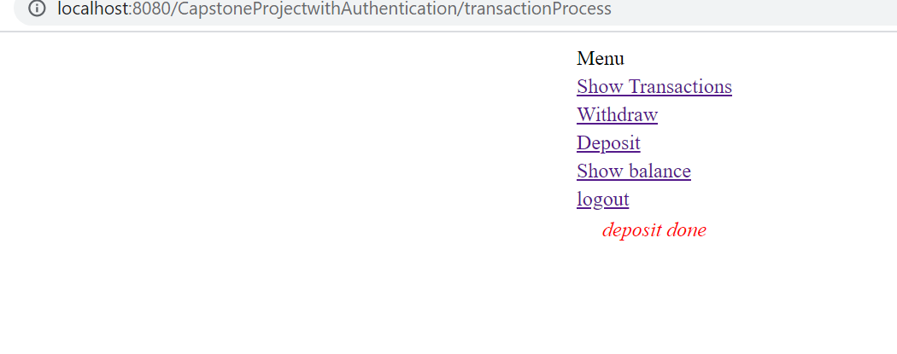

Similarly for the withdraw too

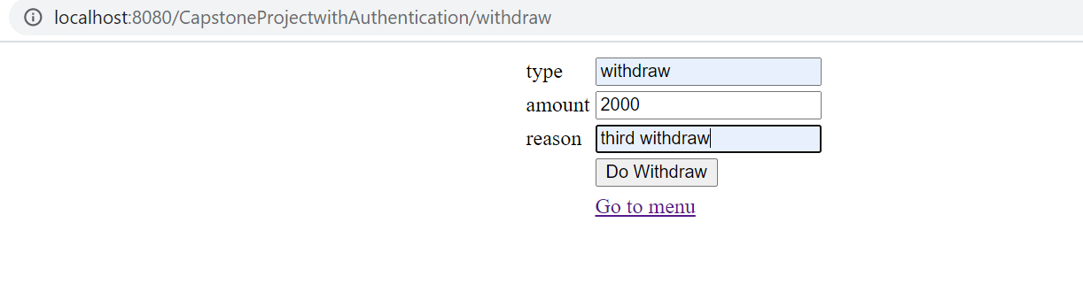

For successful withdrawal

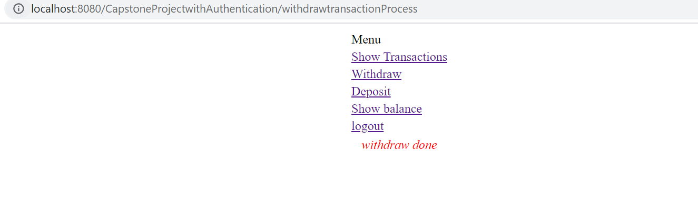

When we select on the show balance then the balance will be shown and u can navigate back by clicking on the go to menu hyper reference.

